|  |  |
| --- | --- |
| Name: Sayyed Sohail Rashid | Course Name: DC-LAB |
| Class: BE-CO | Batch: 01 |
| Roll no: 18CO48 | Experiment No: 03 |

Aim : To Implement the Berkeley Algorithm.

Code:

Berkeley.java

import java.util.*;

public class Berkeley

{

public static int getTime(String time)

{

String[] temp = time.split(":");

int rtime = Integer.parseInt(temp[2]) + Integer.parseInt(temp[1])*60 +

Integer.parseInt(temp[0])*60*60;

return rtime;

}

public static String setTime(int time)

{

String rtime = new String();

for(int i=0;i<2;i++)

{

int power = (int)(Math.pow(60,2- i));

if((time/power)/10>0)

rtime = rtime + time/power;

else

rtime = rtime + "0" + time/power;

time = time%power;

rtime = rtime + ":";

}

if(time/10>0)

rtime = rtime + time;

else

rtime = rtime + "0" + time;

return rtime;

}

public static void main (String args[])

{

Scanner sc = new Scanner(System.in);

System.out.print("Enter number of machines: ");

int n = sc.nextInt();

String times[] = new String[n];

System.out.println("\nEnter current time of machines (HH:mm:ss) : ");

for(int i=0;i<n;i++)

{

System.out.print("Machine " + i + ": ");

times[i] = new String();

times[i] = sc.next();

}

int tot=0;

for(int i=0;i<n;i++)

{

System.out.println("Machine 0 sends TIME = " + times[0] + " to Machine " + i);

int diff = getTime(times[i])-st;

System.out.println("Machine " + i + " replies " + diff + " to Machine 0");

tot+=diff;

}

int avg = tot/n;

times[0] = setTime(st+avg);

System.out.println("\nMachine 0 sets new TIME = " + times[0] + " and sends it to all other machines.");

System.out.println("All machines set their time to "+ times[0]);

}

}

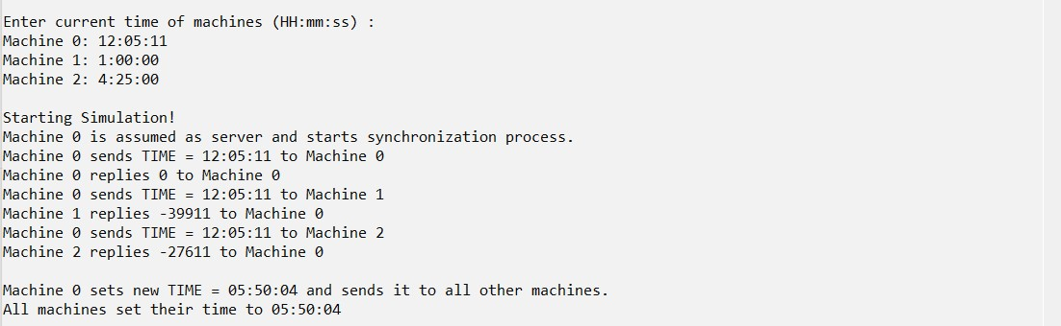

Conclusion**:**

Berkeley Algorithm has been executed successfully and gives the required output.